- Although the Bank of England's Monetary Policy Committee continues to lower Bank Rate, we expect net household interest payments to rise further as mortgagors refinance cheap fixed-rate deals. Alongside softer real pay growth and tighter fiscal policy, the lagged impact of past rate hikes on mortgagors will continue to weigh on consumer spending.
- In contrast, policy rate cuts are passing through to the corporate sector much more quickly. This should support firms' cashflow positions and make external financing more affordable. Nevertheless, we still expect business investment to remain broadly flat given the headwinds from elevated trade policy uncertainty, sharply rising labour costs, and weak profitability.
- Bank Rate is comfortably above most plausible estimates of neutral. Given this, and our view that real activity growth is likely to remain relatively insensitive to looser policy for some time, we think this would mitigate some of the downsides to the MPC adopting a more activist approach to cutting rates than the gradual and cautious path it has pursued thus far.
The Bank of England's Monetary Policy Committee has delivered 100bps of rate cuts since its easing cycle began in August 2024. Although we expect the MPC to continue to gradually lower the policy rate, the lagged impact of the 2022-2024 hiking cycle is still dominating and we don't think looser monetary policy will support an upturn in economic activity over the next couple of years.
Chart 1: We expect firms to benefit from rate cuts more quickly than households
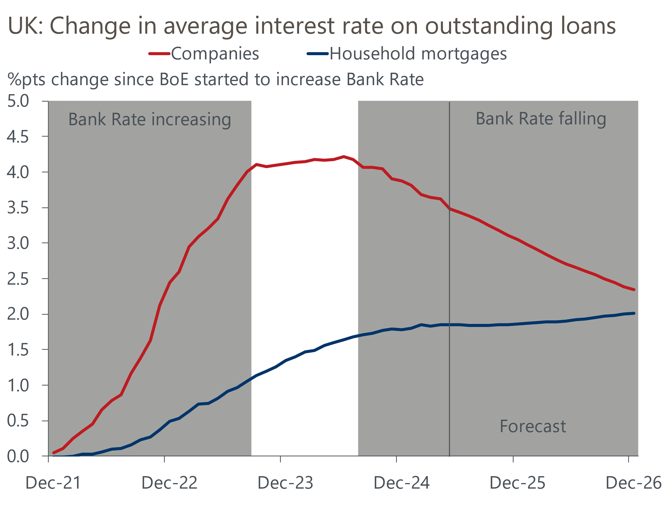
Sources: Oxford Economics, Haver Analytics

Cuts to Bank Rate will continue to pass through to corporate interest rates quickly
Higher debt servicing costs have been a key pressure on corporate finances in recent years. The average interest rate on outstanding loans to private non-financial companies rose by more than 400bps during the BoE's hiking cycle (Chart 1). The relatively quick transmission of past increases in Bank Rate to corporate interest rates is a result of 83% of loans to companies being on a floating interest rate.
This rapid transmission has continued as the MPC has begun to loosen policy. The BoE has delivered 100bps of rate cuts over the past year and the average interest rate on the stock of company loans has decreased by 70bps (Chart 2). Given the BoE is set to continue gradually cutting Bank Rate, we expect corporate interest rates to continue to fall.
Chart 2: Recent cuts to Bank Rate are passing through to corporate interest rates relatively quickly
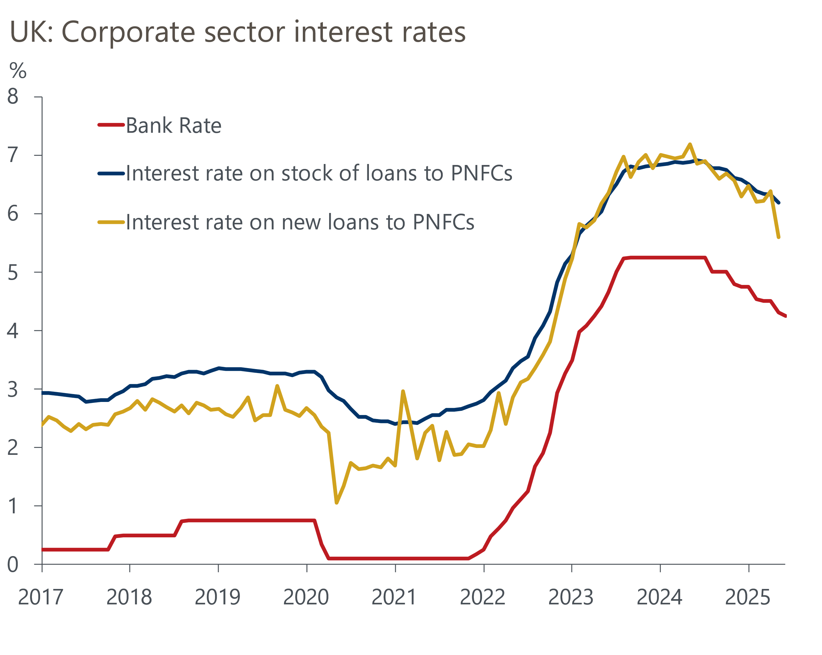
Source: Bank of England

But the transmission of looser policy to household interest rates will be more protracted
The picture for household interest rates looks very different, with the impact of past rate hikes continuing to dominate. The BoE's latest Financial Stability Report reported that around 30% of mortgagors are yet to refinance cheap five-year fixed-rate deals taken out before the BoE started its rate hiking cycle in H2 2021. Almost all of these borrowers on five-year fixes have deals that will expire in the next couple of years and we estimate that these mortgagors will face increases in their mortgage rates of 200-250bps (Chart 3).
Chart 3: Many mortgagors will need to refinance at much higher rates over the next couple of years
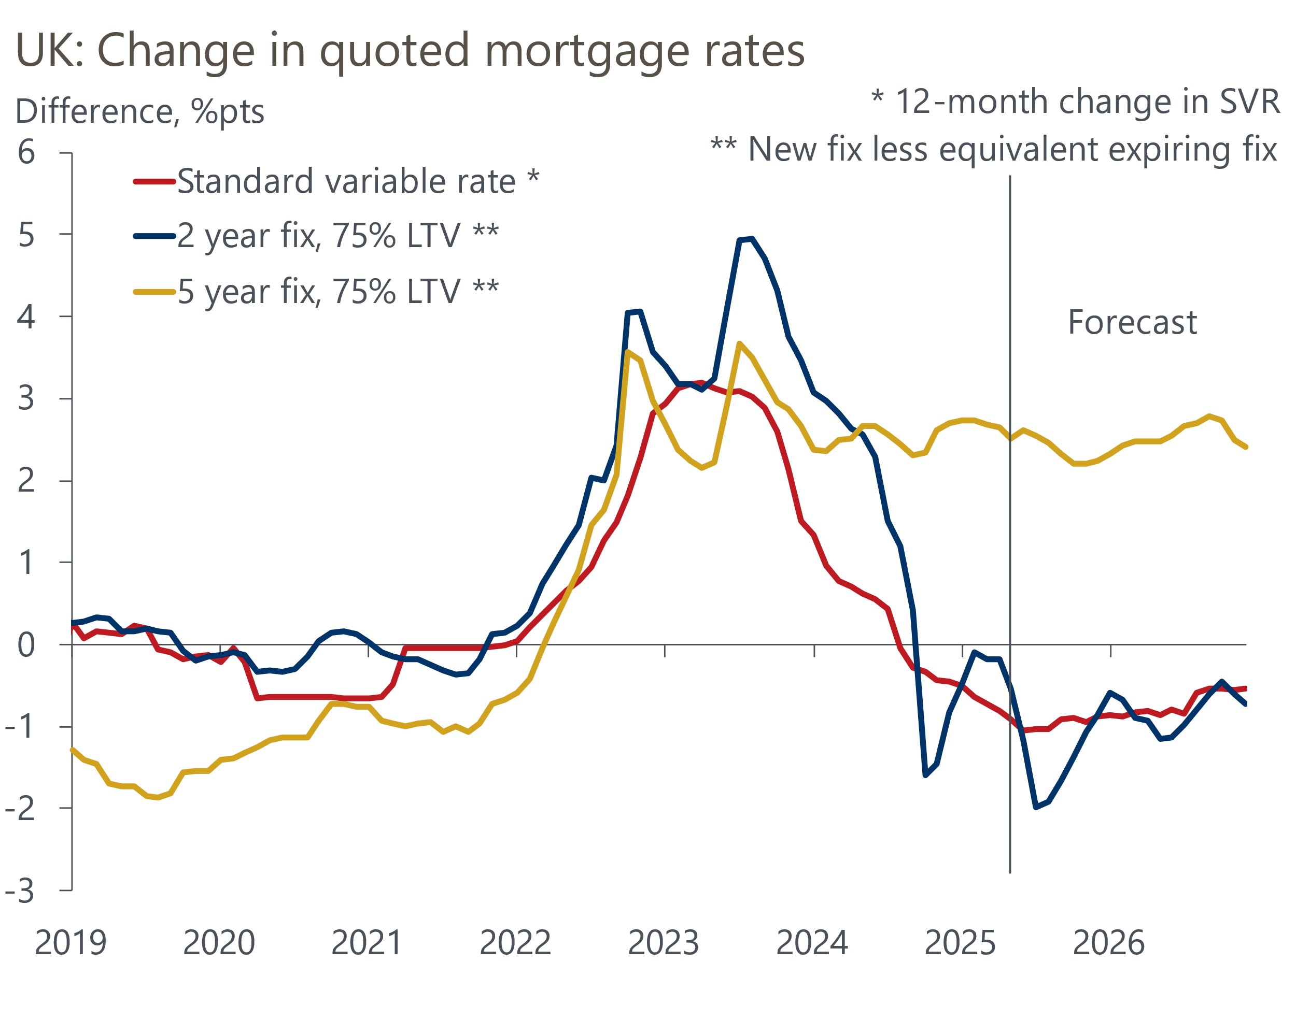
Sources: Oxford Economics, Haver Analytics
However, there will be a wide spread of outcomes for mortgagors. Households coming to the end of shorter fixed-rate deals are likely to benefit from refinancing, following the decline in quoted mortgage rates in recent years. Meanwhile, the 10% of mortgagors on variable-rate deals should also see their monthly repayments fall as cuts to Bank Rate continue.
Nevertheless, there's been a large shift in the structure of the mortgage market over the past decade. Fewer households have mortgages, and product demand from those with mortgages has moved away from floating-rate deals, with five-year fixed-rate deals currently the most popular mortgage product (Chart 4). This means that the transmission of policy rate cuts to mortgagors is now far more gradual than in previous rate-cutting cycles. Given the scale of the increase in monthly repayments facing borrowers who are due to refinance five-year fixed-rate mortgages, and the popularity of these deals, we still expect the effective interest rate on outstanding mortgages to continue to drift upwards over the coming years.
Chart 4: Variable-rate and short fixed-rate mortgages are much less popular than in past cutting cycles
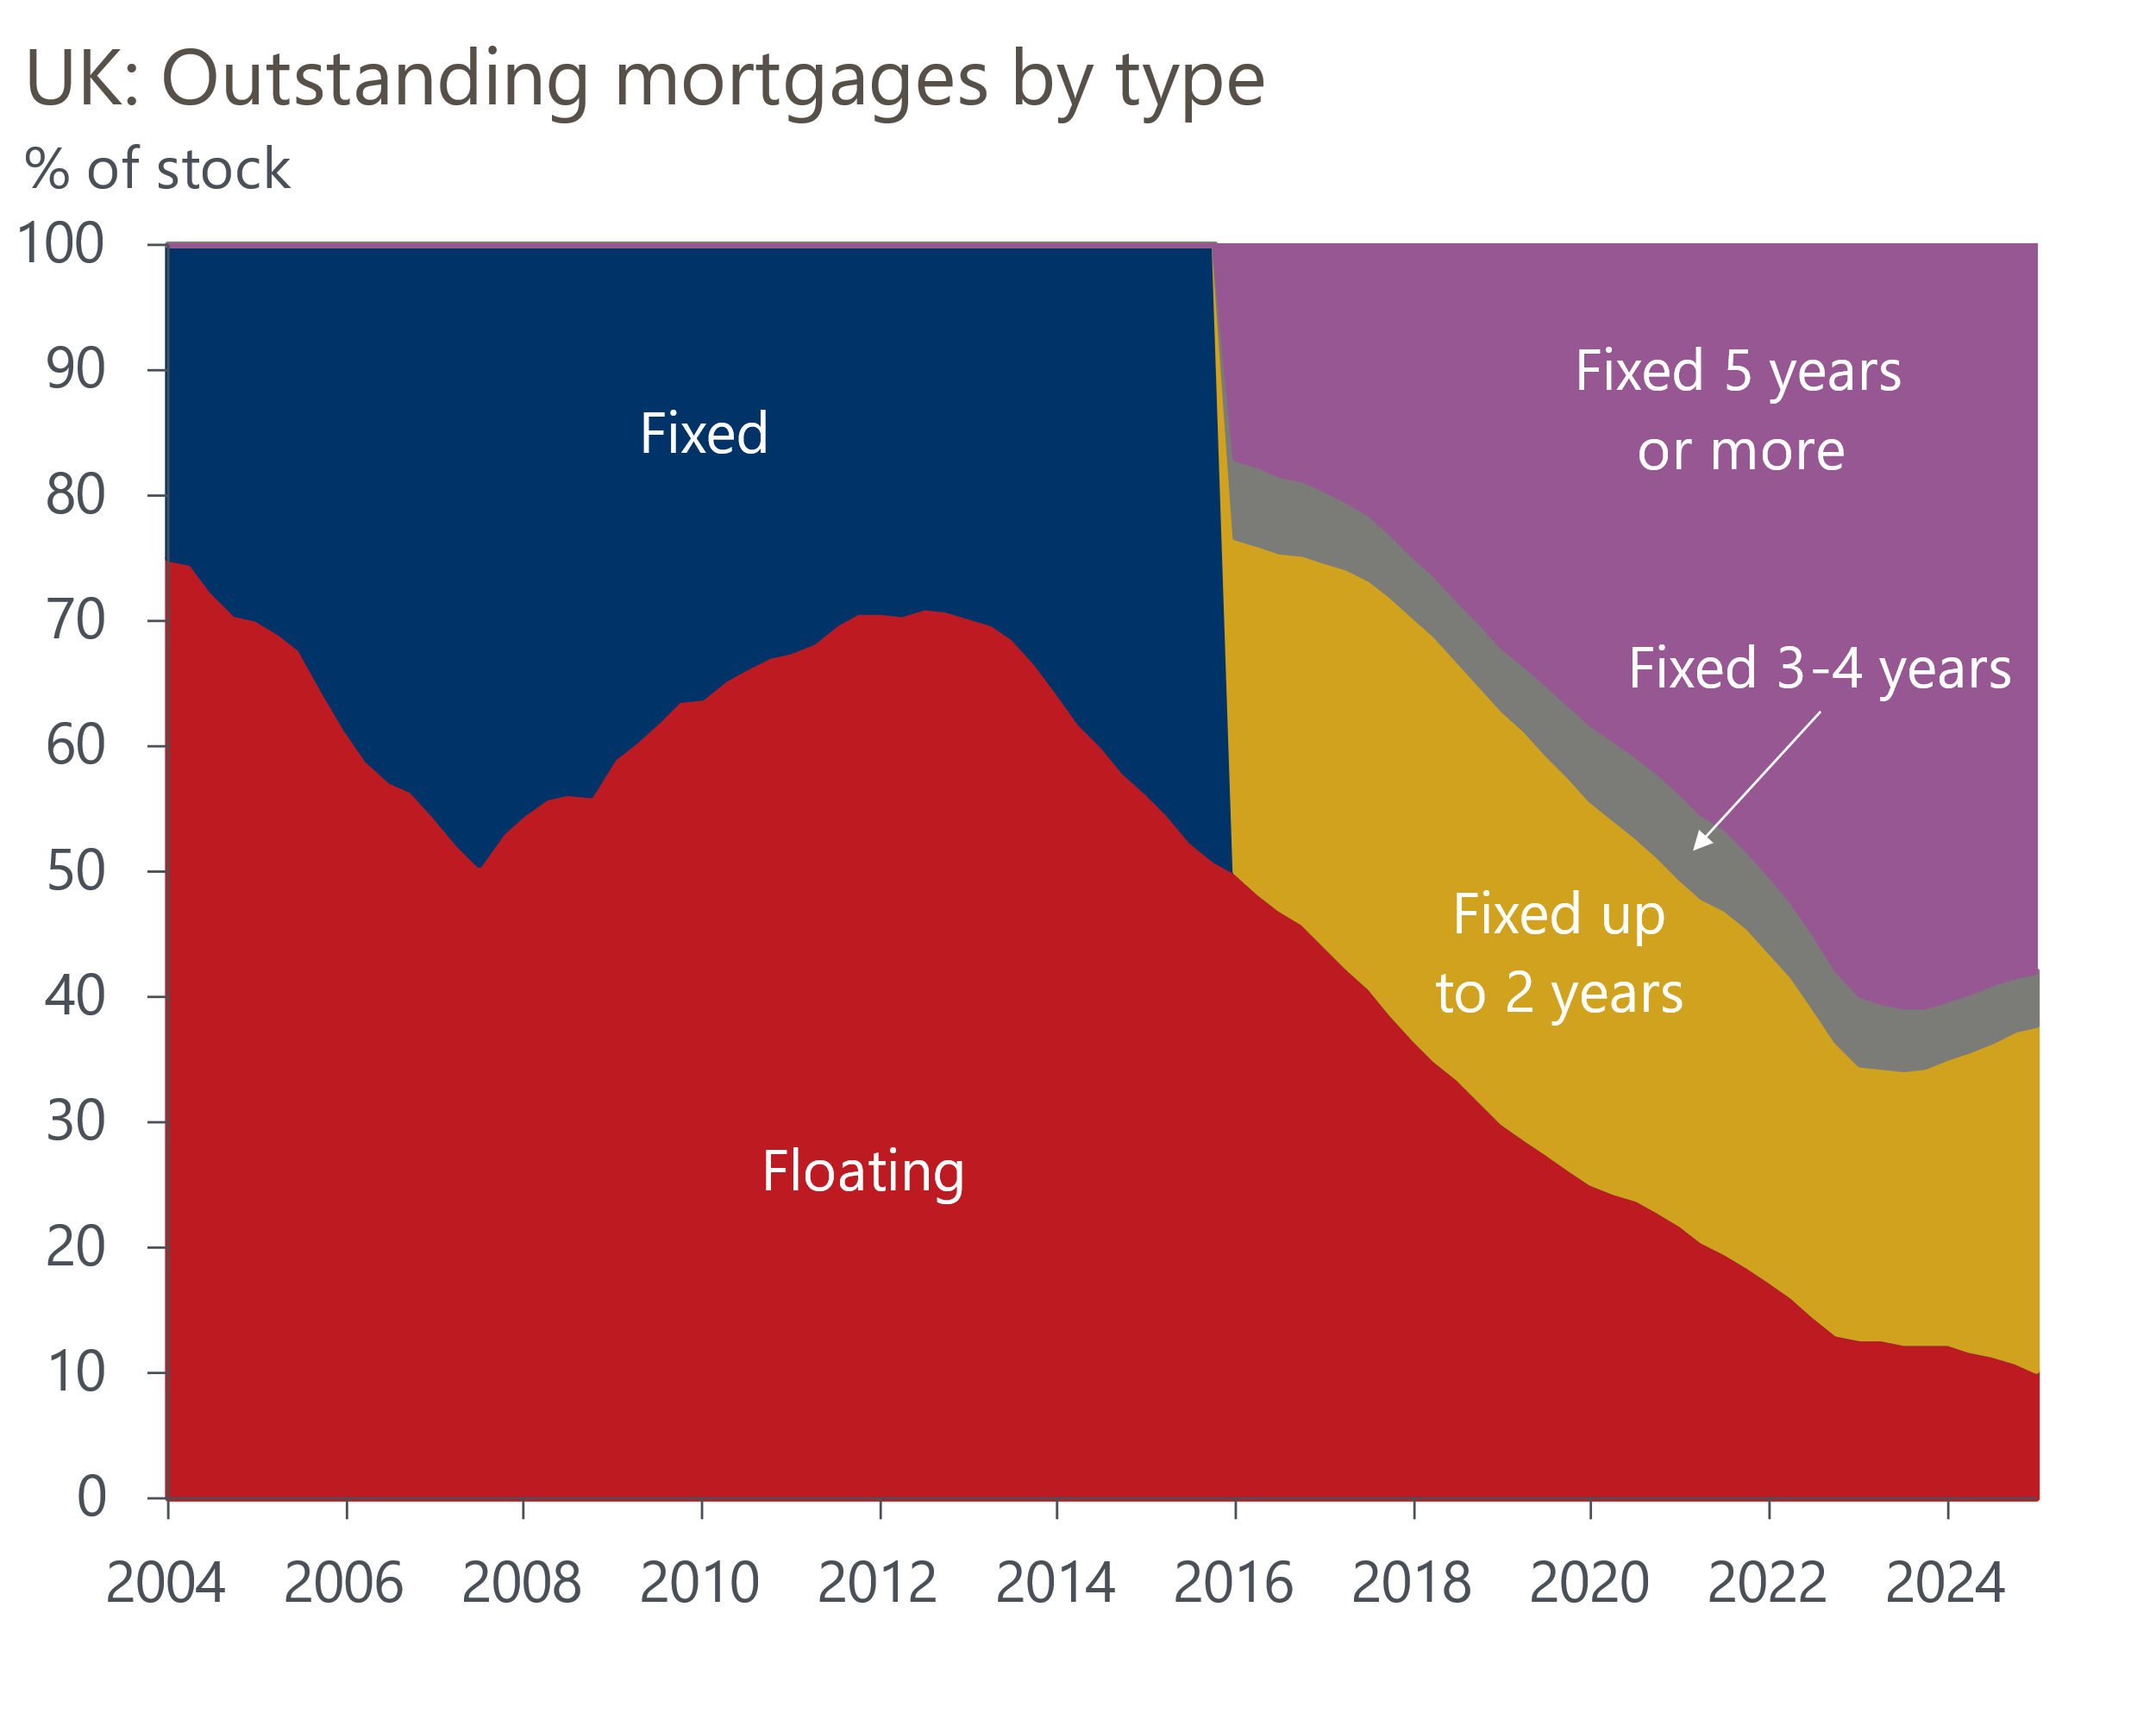
Source: Oxford Economics calculations using data from Haver Analytics
The transmission of recent cuts to Bank Rate to interest rates payable on household savings has also been relatively slow. The interest rate on instant-access sight deposits is down just 26bps from its recent peak, while the interest rate on time deposits has fallen only slightly further. This is a consequence of both the limited pass-through of the BoE's recent tightening cycle to household savings rates, but also increasingly strong competition for deposits between banks.
Overall, the combination of further upward pressure on mortgage debt-servicing payments and the slight downtick in interest receipts from household savings means changes in interest rates will remain a net negative for household incomes this year and next, before the squeeze starts to fade from 2027 (Chart 5).
Chart 5: The drag from net interest payments on disposable incomes will grow this year and next
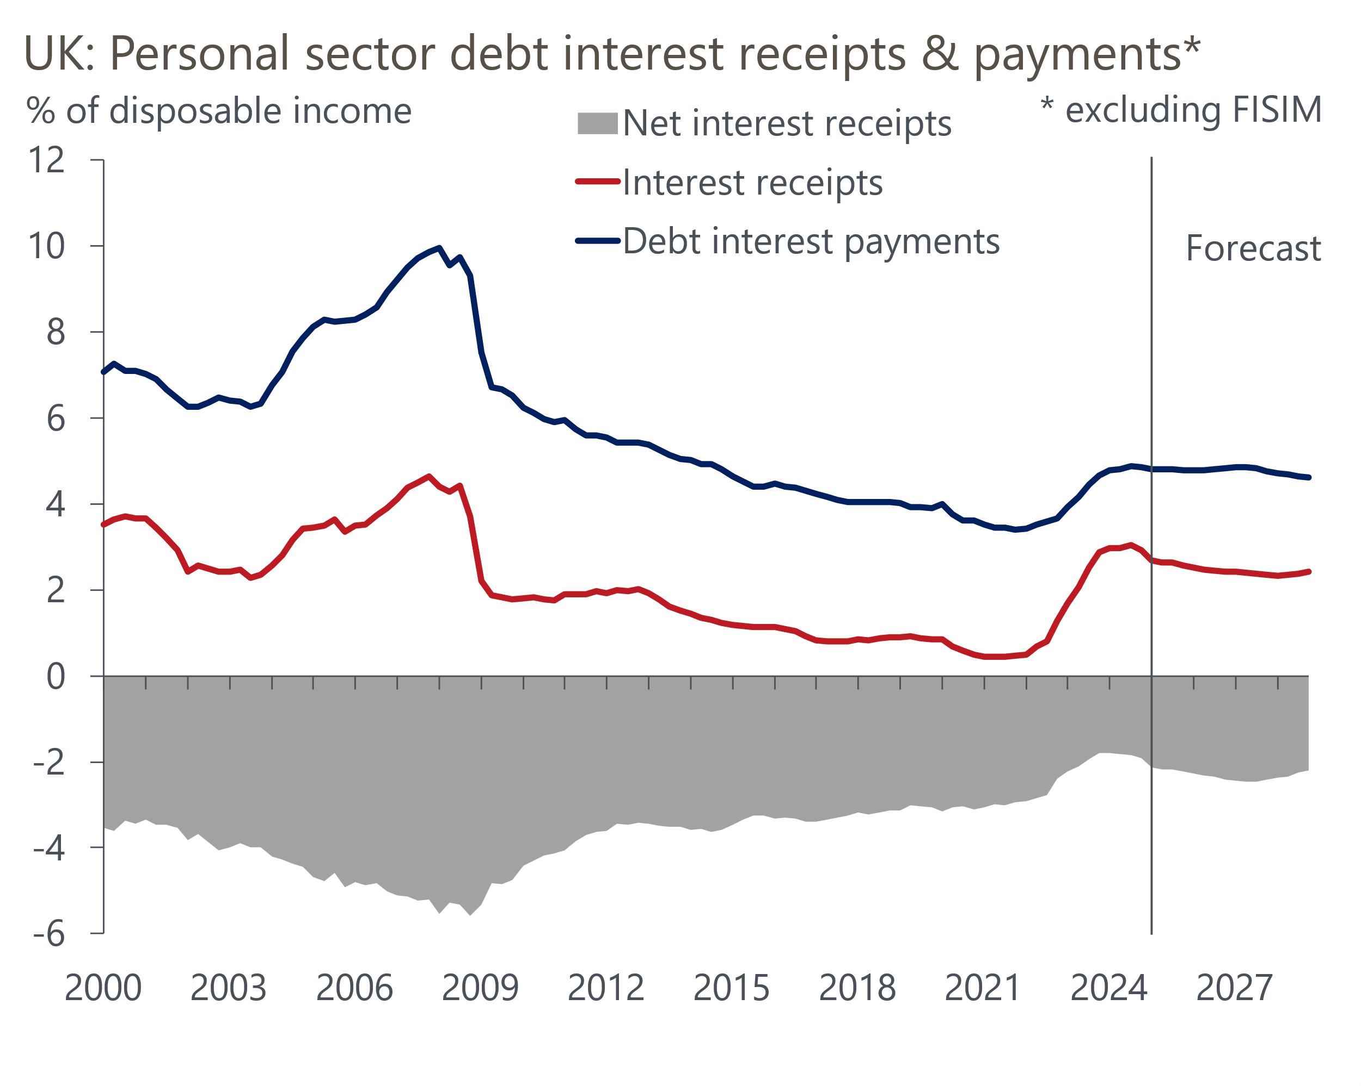
Sources: Oxford Economics, Haver Analytics

Looser monetary policy will remain a blunt tool for supporting real activity growth
Although we expect the speed at which cuts to the policy rate are reflected in corporate and household interest rates to differ significantly over the coming years, the overall boost to economic activity from lower interest rates is likely to be limited.
There are several channels through which changes in corporate interest rates can influence economic activity. First, the fall in debt servicing costs associated with lower corporate interest rates should improve companies' cashflow positions. In turn, all else being equal, this provides greater availability of internal financing for investment and hiring plans. Second, as corporate interest rates fall, debt-financed investment becomes relatively more appealing. Third, a lower cost of capital reduces the hurdle rate on capital expenditure, resulting in a greater variety of investment projects that a given firm can pursue.
However, we're sceptical that lower corporate interest rates will deliver a material upturn in business investment in the near term. This reflects the strength of other factors that are weighing on the ability and desire of firms to invest. Corporate profitability is at its lowest level in more than 20 years, and the upward pressure on labour costs from recent rises in employers' national insurance contributions and the national living wage is likely to more than offset the benefits from lower corporate interest rates. Elevated trade policy uncertainty and weak consumer demand mean the climate for committing to multi-year capital projects is poor. Moreover, there's also evidence that hurdle rates and business investment respond relatively sluggishly to changes in the cost of capital. Therefore, although corporates will certainly welcome lower debt servicing costs, we still expect business investment to remain broadly flat over the next couple of years.
On the household side, together with the drags from softer real earnings growth and the freeze on most tax thresholds and allowances, we expect the lagged impact of past interest rates to result in much weaker growth in real household incomes over the next couple of years.
Consumers have exercised extreme caution in recent years, with the pickup in spending lagging well behind the recovery in real incomes. Surveys suggest consumer sentiment is starting to pick up a little, and this should mean households will gradually become keener to spend and take on more credit. Lower interest rates on savings may also help this along. But even allowing for an improved consumer mindset, the slowdown in real disposable income growth – particularly for mortgagors and renters, who typically have a higher marginal propensity to consume than other households – is likely to mean that spending growth remains fairly sluggish.

Limited policy transmission mitigates some downsides of the MPC cutting more quickly
Bringing all of these factors together, we think a challenging corporate outlook and the lagged impact of past rate hikes on mortgagors continuing to emerge mean the BoE's rate-cutting cycle is unlikely to provide much of a tailwind for business investment and consumer spending over the next couple of years.
Given the sluggish transmission of recent rate cuts to activity, and that Bank Rate is still comfortably above most plausible estimates of neutral – the BoE's Market Participants Survey suggests a neutral rate of between 3% and 3.5% – we think this would mitigate some of the downsides to the MPC relaxing its "gradual and careful" approach to loosening policy. However, the speed of monetary transmission isn't the MPC's only consideration when setting Bank Rate and it's currently prioritising other issues, including underlying inflationary pressures, labour market conditions, and seeking to maintain the committee's inflation-fighting credibility.
Nevertheless, that real activity growth will probably remain relatively insensitive to looser policy for some time is one key factor behind why we view a scenario in which the MPC lowers Bank Rate more quickly than markets expect as more likely than one in which the committee takes a more cautious approach to cutting.

